**CN LAB 01**

**SUBMITTED BY: AYESHA ZIA(20K-0414)**

**QUESTION 01**

**Command:**



**IP Address:**

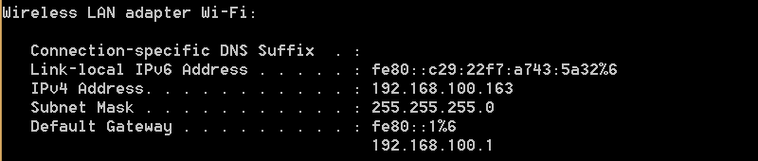

**QUESTION 02**

**IP ADDRESS(DONE IN Q1)**

**Command:**



**MAC ADDRESS and DHCP Enabling:**

MAC ADDRESS

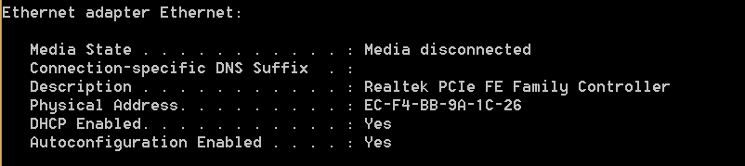

DHCP

**QUESTION 03**

**Command:**



**Hostname:**



**QUESTION 04**

(Checking connectivity with website)

**Command(by name):**



**Connectivity:**

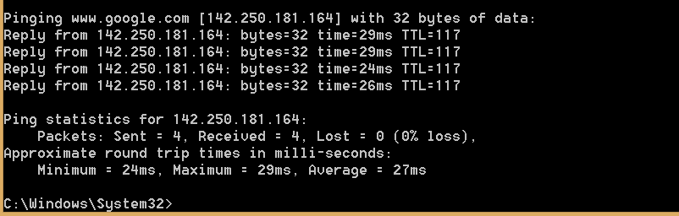

**OR**

**Command(by IP Address):**



**Connectivity:**



**How can basic IP connectivity be checked?**

**Answer:** The ping command sends packets of data to the speicified IP address and returns the response time which shows that whether there is connectivity between the IP-networked devices or not.

**What are the reasons for no connectivity?**

**Answer:**

One reason can be that the computers might not be on the same network. For example, one PC might be using one ISP(through WiFi) and the other PC might me connected to another WiFi. Also, network discovery must be enabled on both the computers to ensure successful connectivity.

**QUESTION 05**

**Command:**



**MAC Address of Host:**

MAC ADDRESS



**QUESTION 06**

**Command:**



**Answer:**

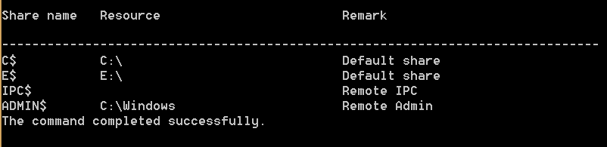

**QUESTION 07**

**Browser connected:**

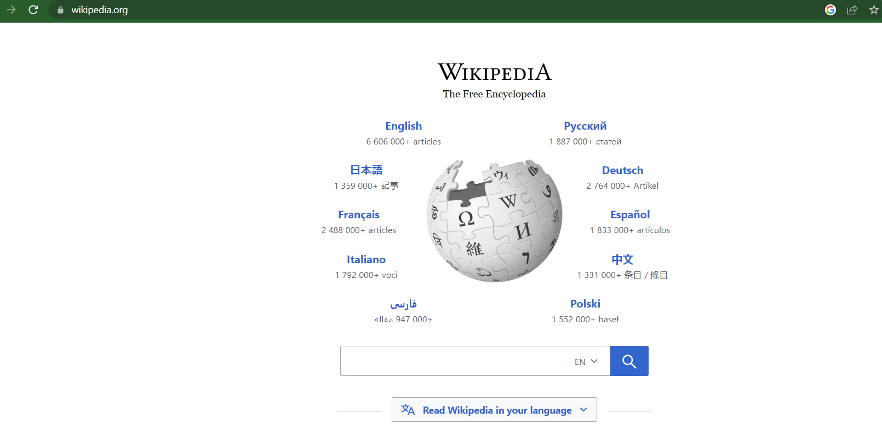

**Command:**



**Answer:**

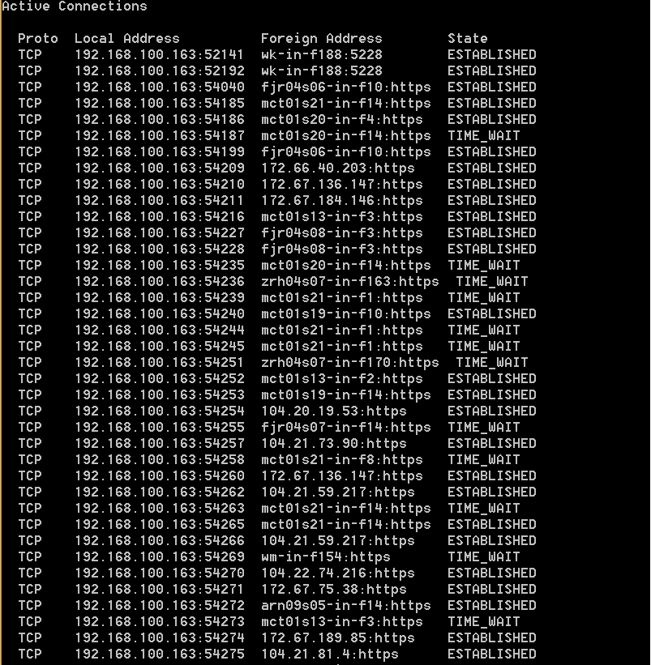

**QUESTION 08**

**Command:**



**Answer:**

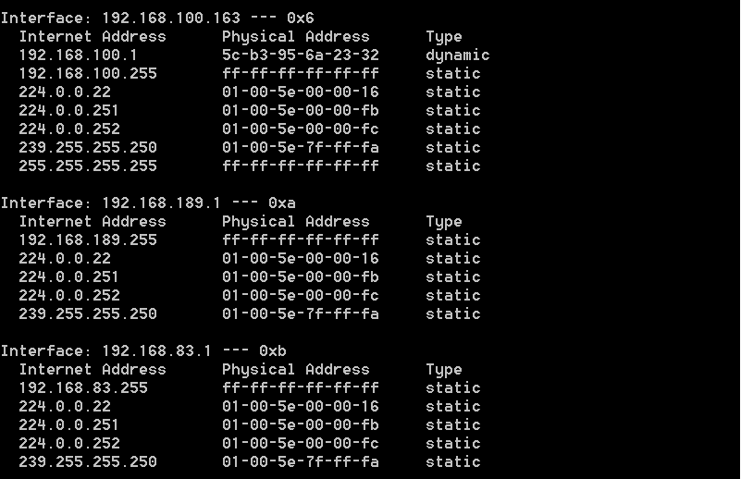

**QUESTION 09**

**Command:**



**Answer:**



**QUESTION 10**

**Command:**



**Answer:**

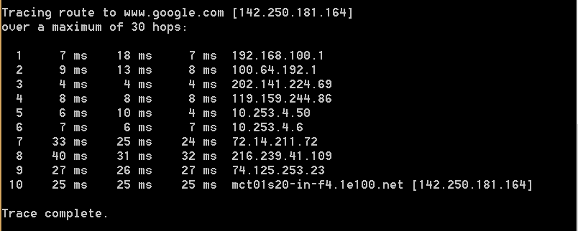

IP Address

HOPS

**QUESTION 11**

**Reason:**

It fails because the host blue is not available so it is not accessible. However, the IP address works because it is the default IP address used by many wireless router manufacturers to redirect to the admin panel of the router.

**QUESTION 12**

**Answer:**

I will prefer fibre optic cable for connection in my home for the following reasons:

1. **High Bandwidth:** These cables offer a much better bandwidth in contrast to the standard metal. It also transmits signinifcantly a greater amount of data per unit time.
2. **Better Speed:** To meet the needs of fast browsing, the fibre optic cables are faster than even the best copper wires as their range varies between 5 Mbps to 100 Gbps.
3. **Durable:** Fibre optic cables are much lighter in weight and thinner in size. They can also withstand more pressure and resist corrosion in contrast to copper wires that are more prone to damage.

**QUESTION 13**

**Answer:**

We can connect a switch to another switch using straight through cable if one switch is using an uplink port and other one is using a normal port. The same is possible to connect a router with PC as straight through cable can be used to connect two different devices. One end of the cable is inserted in the modem while the other end is plugged into WAN/WLAN port of the router.

**QUESTION 14**

**Answer:**

An example of network within my home is how different devices are connected to the same internet connection using WiFi. This is an example of **Star Network Topology.** The Internet Service Provider(in my case Optix)provides internet connection to my home through a WiFi router. All the other devices in the home including phone, laptop can then access the internet by connecting with the WiFi connection that the router is providing. The IP address of the router on the devices is same. However, the individual IP address of the devices connected to the internet varies.

**QUESTION 15**

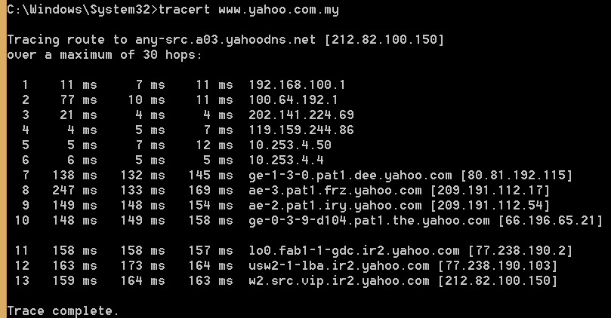

HOPS